# Informing Infrastructure Decision-Making through Large-Amplitude Forced Vibration Testing

N. Gucunski (PI)1,2, F.L. Moon (Co-PI)1,2, and John DeVitis (Co-PI)2

*1Department of Civil and Environmental Engineering*

*2Center for Advanced Infrastructure and Transportation (CAIT)*

*Rutgers University*

## Project Vision

Although originally envisioned for seismic-related research, the large-amplitude mobile shakers that are available through the NSF NHERI Program offer significant potential to overcome some of the most daunting assessment challenges facing transportation agencies. This potential lies in the shakers’ ability to impart large-amplitude forces (30 to 60 kip) at relatively low frequencies (5 to 15 Hz). Such large energy inputs will not only overcome intermittent stick-slip mechanisms that currently hamper low-amplitude assessment approaches, but will also permit the identification of the onset of nonlinearity (which is particularly important for soil-foundation-substructure assessment).

## Project Objectives

The overarching aim of the research proposed herein is to explore and establish the ability of large-amplitude, forced vibration testing to reveal the current performance and forecast the future system performance of common highway bridges. To meet this goal, the following more focused objectives will be pursued:

1. Develop, evaluate, and refine a series of forced vibration testing strategies to capture response measurements indicative of key performance attributes of substructure/foundation and superstructure systems
2. Develop, evaluate, and refine a series of both model-free‡ and model-based† data interpretation frameworks for bridge system (foundation-substructure-superstructure) identification and assessment
3. Perform a validation of the testing strategies and data interpretation frameworks on an operating highway bridge with known substructure and foundation characteristics

## Intellectual Merit

The intellectual merit associated with the proposed research lies in the examination of large-amplitude forced-vibration testing to assess and identify existing superstructure-substructure-foundation systems. Although various cost-effective dynamic testing methodologies for bridge systems have been developed, they all suffer from a reliance on low-amplitude excitation, which is unable to overcome intermittent stick-slip mechanisms or to induce appreciable responses within the substructure-foundation system. The mobile shakers available through the NSF NHERI Program have the potential to overcome this shortcoming. This research aims to establish their potential in this regard and also to begin the development of new data interpretation frameworks that do not rely on the linearity of the system being tested.

_______________________________________________________________________________________________________

‡ Model-free data interpretation refers to methods based primarily on data processing, data visualization, and data fitting techniques. Examples include the use of impedance, time-frequency analysis, modal parameter identification, etc.

† Model-based data interpretation refers to methods that update simulation models of the system being identified, and then employ these models to examine behaviors that cannot be directly observed. In the realm of constructed systems this approach is referred to as Structural Identification (St-Id) and typically involves the updating of finite element (FE) models through either deterministic or probabilistic (Bayesian updating, multiple model) methods.

## Broader Impact

The primary broader impact of this effort resides in the realm of infrastructure renewal. With the ability to perform reliable, quantitative assessment of superstructure-substructure-foundation systems of aging bridges, owners will be provided with reuse options currently unavailable (NCHRP 24-25). In cases where the condition of the substructure-foundation systems will permit reuse, owners can realize significant savings and can employ accelerated bridge construction (ABC) approaches, which drastically reduce disruptions and maintain mobility. In addition, the proposed large-amplitude vibration testing will be capable of overcoming unreliable behavior mechanism to support more accurate capacity estimation. Currently over 65,000 bridges are posted for less-than-legal loads. Although testing methods exist, they are either too costly or reliant on low-level responses which are difficult to extrapolate for capacity estimation.

The research team will incorporate the findings of this research to support outreach activities to attract high school students and students from under-represented groups to engineering.

## Past Research

The research most relevant to the proposed project includes studies focused on the identification and assessment of either bridge substructure-foundation systems or bridge superstructures. The following subsections provide a summary of the key aspects of these research areas.

### Bridge Foundation-Substructure Identification and Assessment

* Most of the work in this area has been done in order to identify the type of unknown foundations to better characterize their vulnerability to scour.
* The work by Olson et al. (NCHRP Project 21-05), which aimed to identify unknown foundation types through the use of vertical shakers together with simple FE models, is particularly relevant to the proposed research.
* The key distinguishing characteristics of the proposed research include:
  + The use of horizontal excitation as opposed to only vertical, as well as their combination. This will allow responses far more sensitive to soil-foundation type and stiffness to be obtained. This becomes especially important for bridges with high height-to-width ratio where the rocking response of foundations may have a dominant effect on the swaying and torsion of the superstructure.
  + The use of a more comprehensive and extensive monitoring of the dynamic response on the surrounding soil, foundations, substructure and superstructure will enable capturing of the interaction effects and estimation of foundation impedance functions.
  + The use of more sophisticated data interpretation frameworks inclusive of both model-free and model-based approaches. Olson et al. focused on very simplistic FE models together with deterministic model updating algorithms.



**Figure 1** – Vibroseis truck delivering vertical excitation to a bridge pier (Olson et al. 2005)

### Bridge Superstructure Identification and Assessment

* Extensive research has been conducted on the development and validation of techniques to estimate live load capacity, fatigue vulnerability, seismic performance, etc. An extensive review of these techniques was provided by Moon and Aktan 2006.
* In the realm of dynamic testing of bridges, most work has focused on ambient vibration monitoring although forced vibration testing techniques (using both small shakers and various impact devices) have also been studied (Aktan et al., Brownjohn et al., Brown et al,, etc.). Such testing was unable to capture the effects of soil-foundation-substructure interaction, which would become critical in the actual response of a bridge to extreme loads, like earthquake loads.
* The research most relevant to the proposed research is the recent development and validation of the Targeted Hits for Modal Parameter Estimation and Rating (THMPER) System (Devitis et al.).
  + This system is composed of a testing trailer/vehicle capable of carrying out modal impact testing of highway bridges in a rapid manner (approximately 30 min per span) with only partial closures.
  + The primary shortcoming of the THMPER System is that the short duration of the impact (approximately 0.02 sec) is not able to overcome intermittent, stick-slip mechanisms.
  + Although the use of large shakers will add considerable time and require full closures, the ability to load the bridge to larger force levels will produce more reliable estimates of capacity.

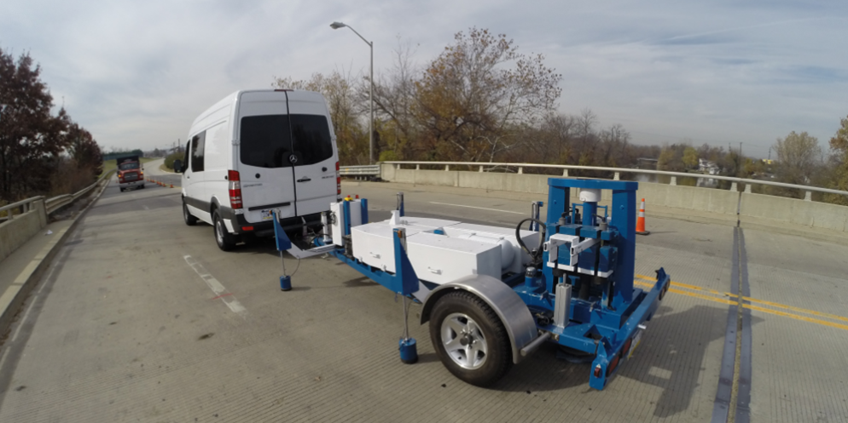

**Figure 2** – Photograph of the THMPER System during a recent test of a highway bridge

## Research Plan

The research plan is broken into three tasks that are associated with each of the objectives listed above.

### Task 1 – Development of Forced-Vibration Testing Strategies

* This task will begin by designing a parametric study to examine the correlation between certain measureable responses and the foundation/substructure type/condition. It is envisioned that the following parameters will be included:
  + Soil-foundation elastic and nonlinear properties (indicative of different foundation systems, e.g., piles, drilled shafts, footings, etc.) incorporated through impedance functions (frequency dependence) and large deformation (strain dependence)
  + Substructure type (multi-column piers, hammerhead piers)
  + Substructure aspect ratios (height-to-bridge width)
  + Superstructure type (PS concrete vs steel, and continuous vs simple span)
  + Transverse distribution parameters, including the presence of low-level stick-slip mechanisms
* It is envisioned that these parameters will be sampled either through a full-factorial approach (for discrete parameters) or through a latin hypercube approach (for continuous parameters)
* 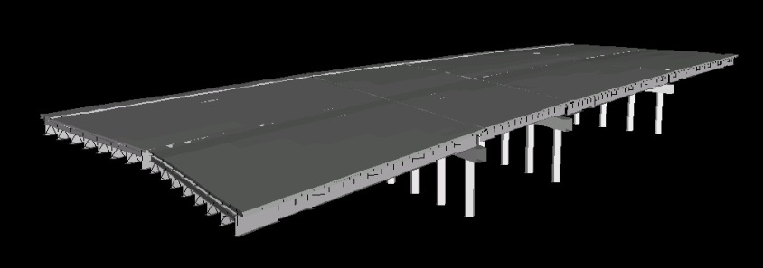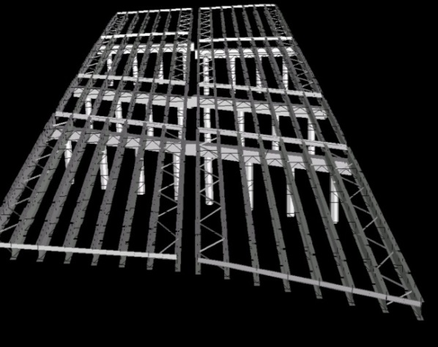Once completed, 3D FE simulation models of each notional bridge system will be constructed via the Strand7-Matlab API using software previously developed

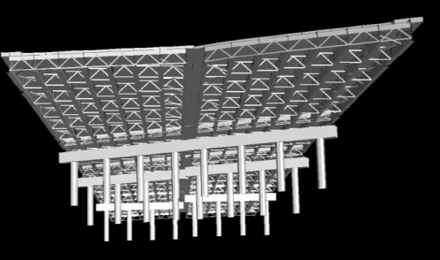

**Figure 3** – Example 3D FE model of bridge super- and substructure systems developed through the Matlab-Strand7 Application Programming Interface (Dubbs and Moon 2016)

* This suite of bridges will then be subjected to various dynamic inputs (frequency, direction, location, etc.) to identify response metrics that are sensitive to changes in the selected parameters across the population
* Using this information the research team will identify a strategy or strategies on how to best utilize the large-amplitude NHERI shakers to collect the identify metrics

### Task 2a – Development of a Model-Free Data Interpretation Framework

* This task will focus on the use of impedance functions, or simplified dynamic soil-foundation models, and will utilize the same suite of bridge system models developed under Task 1
* In particular, this task will aim to establish how sensitive and robust the model-free techniques are when exposed to data with various levels of measurement noise and spatial resolution/density

### Task 2b – Development of a Model-Based Data Interpretation Framework

* Using the same suite of FE models develop under Task 1, this task will examine the ability of using various St-Id approaches to identify the changes in the soil-foundation-substructure parameters and the transverse distribution parameters (which have significant influence over capacity estimations) sampled under Task 1
* This task will identify both nonlinear and smeared linear models using the St-Id technique listed below to assess both sensitivity and robustness
  + Conventional deterministic model updating (Chen and Garba 1980; Imregun and Visser 1991; Hjelmstad et al. 1992; Mottershead and Friswell 1993; Sanayei et al. 1999; Mares et al. 2000; Brownjohn et al. 2003)
  + Threshold method (Robert-Nicoud et al. 2005, Smith and Saitta 2008, Kripakaran and Smith 2008, Goulet et al. 2010)
  + Semi-deterministic multiple-model method (Dubbs and Moon 2016)
  + Bayesian model updating (Beck and Katafygiotis 1998, Ching and Chen 2007)

### Task 3 – Field Implementation and Validation

* This task will focus on the field implementation of the most promising testing strategies and data interpretation frameworks (identified in Tasks 1, 2a and 2b) on an actual bridge.
* The test bridge will be selected based on:
  + Access issues as well as the presence of detailed information on the substructure and foundation systems. The research team has well established relations with a number of regional transportation agencies (NJDOT, Delaware River Port Authority (DRPA), Delaware River Joint Bridge Toll Commission (DRJBTC), New Jersey Turnpike Authority (NJTA)), which will be of high benefit in selecting best candidate bridge(s).
  + Discussions with the NHERI team at the University of Texas at Austin (UTA) regarding the shaking (forced vibration) scenarios.
* A detailed test plan based on the results of Tasks 1, 2a, and 2b will be developed and carried out with a UTA shaker (preferably T-Rex) and dense instrumentation arrays.
* The results will then be compared against the models within the parametric study to place the field test in context, and to develop recommendations for future research and implementation of the research products into practice.
* The testing will be also used as an opportunity to compare the results obtained from the bridge excitation using a NHERI shaker (vertical mode only) and THMPER, which is owned and operated by the research team.

## Dissemination of Results (to be included in the full proposal)

## Education and Outreach Component (to be included in the full proposal)

## Results from Prior NSF Support (to be included in the full proposal)

## Time Schedule and Budget

The proposed project duration is 12 months. Tasks 1 and 2 will be executed in the first 8 months of the project. Planning for Task 3 will begin with the project award with field testing expected between months 8 to 10. The last two months of the project will be used to summarize the project findings. The estimated project cost is $196,880.